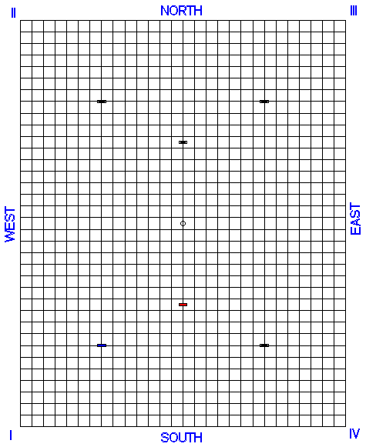

Colours: delete inapplicable, underline if opponent responsible for position.
BLUE/GREEN
Player: Clip on:
BLACK/BROWN
Player: Clip on:
RED/PINK
Player: Clip on:
YELLOW/WHITE
Player: Clip on:
Court No.: Date:

Bisques left:

Next to play:

Ref./Player Signatures:

Lift pending?: Yes / No

Time Limit:

Time Left:

