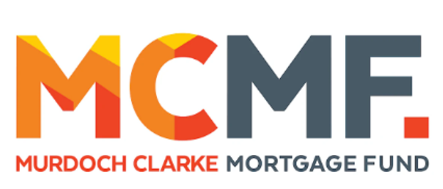


MCMF 19 Point Refund Policy – 2027
- When you withdraw | Refund
- Before the closing date | 100%
- Within 48 hours of an offer being received to participate in the Qualifying Event | 100%
- After the Closing Date and before the draw is published (no later than a week before the event) | 50%
- After the draw has been published | 0%
- If you play in the qualifying event and not successful in moving onto the main event | 50%

Additional Information:
- Written withdrawal of the event needs to be email to the Tournament Manager at kcc19point@gmail.com prior to the timeframes indicated above
  - Please include your bank details
- Refunds will only be made by direct transfer to a bank account and will be made after the conclusion of the event

Margaret Pinkard
Tournament Manager
MCMF 19 Point Tournament
kcc19point@gmail.com

